Running head: VISUAL ANALYSIS FINAL DRAFT

Texting and Driving is a Huge Risk: An Analysis of a National Highway Safety Administration Public Service Announcement

Divyajitsinh Mahida

University of Arkansas Little Rock

VISUAL ANALYSIS FINAL DRAFT

Texting and Driving is a Huge Risk: An Analysis of a National Highway Safety Administration Public Service Announcement

Imagine you are driving down the road simply texting your friend that you are on the way. Suddenly you find your body slamming against the steering wheel, head crushing against the windshield, hospitalizing and the other driver due to a head-on collision. And you are facing major financial problem because of yours and other driver’s insurance money. In today's life, the big problem we are facing regarding road violation is texting and driving. From my research I found, 4,367 people died in car crashes in 2018 due to cell phone use. And more than 50,000 people were badly injured in car crash due to cell phone use (Texting and Driving Accident Statistics, 2018). I also found that percentage of teenager and adults are higher in car crash due to cell phone use than old age peoples (Texting and Driving Accident Statistics, 2016). Texting while driving is dangerous for all drivers and their passengers. This PSA is on the same problem, it is on texting and driving. This PSA gives you the information regarding the problem we all are going through. The creators of this public service announcement (PSA) is the ad council in collaboration with the National Highway Traffic Safety Administration (NHTSA). I am going to start my analysis of the PSA by looking at the message and purpose of the PSA.

This PSA is effective in appealing to the audience, which is people who text and drive or those who are in the car with someone who texts and drives. It gives a good message to people who text while driving and for the people who sit beside them who text and drive. All the drivers must take care of the rules and stops texting while driving. The audience is able to easily understand the PSA because it is a simple message.

If you want to understand this PSA, you must first look at the text written in white on the PSA. Another big thing is the person in the PSA. The picture is very creative, and it also goes with the idea and the message they are trying to tell us.

Now I am going to talk about the rhetorical situation. The organization behind this PSA is the Ad Council and the National Highway Traffic Safety Administration (NHTSA). The intended audiences behind my PSA are those people who don’t follow the rule and text while driving. Secondary audiences are those people who sit on the passenger seat and don’t stop his or her driver who is texting while driving. I know the intended audiences because it is clearly stated in the PSA. Because they have provided informative text in the ad, that text gives the main message.

By this PSA the author is trying to tell the audiences. If you text while driving, you are risking your life as well as others. Texting and driving is a leading cause for accidents and could leads to major injuries like specific injuries or even death. You should take care of this right now or else it will become dangerous for everyone. Through the message's author trying to convince the audience. The purpose of this text is that after looking at this text, audiences will understand what big mistake they are making by texting while driving. Authors didn’t feel any type of problems during the creation of this PSA.

Now I am going to discuss the visual design of this PSA. The first thing the audience will see in this PSA is the text. Because the text is written in big, white font, which is very informative and eye–catching both. Placement of the text is in the middle and very well placed on the PSA. Because of this, it makes audiences see easily and understand the message quickly. Also, the placement of the message is on the right side and easy to see for the audience. Placement of the different elements guide the audience on what this is. I really like the use of color on the PSA, they used very few colors, but very attractive color like authors have use the white color for text and black color for the background. Due to this it looks like kind of warning and that’s what authors trying to do by this PSA. The PSA has large, easily readable font. The Font gives a big impact on the audience. Because the text is so large, the audience can read it easily and understand the point of PSA clearly. The mood of the font is kind of serious because of black and white color.

Now I am going to talk about Ethos, Logos, Pathos, and Kairos. Authors have attempted to establish credibility, by putting a text in the PSA, authors have established credibility. The text given in the PSA gives a good message to the audiences. Also, the image gives a good message and attracts the attention of audiences. The PSA presents an ethical argument to the audience. Texting while driving is dangerous for you and other drivers. And, it is against the rules, so audiences must be careful while driving. They should not text while driving. These arguments are not only for the targeted audience, but it is for anyone. The authors have presented the logical argument. The logical arguments are that texting, and driving are against the law and dangerous. And it makes sense to targeted audiences. The PSA attempt to appeal in emotions, by using the emotion of convincing. The Ad Council and the NHTSA try to convince through the text provided in the PSA that the audience should not text while driving. The text says, “DON’T LET TEXTING BLIND YOU” (Ad council and NHTSA, 2015) . I got to know by the text they used in the PSA. The text is very convincing.

From my research, this PSA was published in 2016. In 2015, The National Safety Council reports that cell phone use while driving leads to 1.6 million crashes each year. Nearly 390,000 injuries occur each year from accidents caused by texting while driving (Texting and Driving Accident Statistics, 2015). In 2015, 3,477 people were killed in USA because of using phone while driving. But in 2016 the ration decreased by 2% and it is the big achievement for us (Texting and Driving Accident Statistics, 2016). Fatalities in distraction – affected crashes decreased from 3,526 in 2015 to 3,450 in 2016, or a decrease of 2.2 percent (Texting and Driving Accident Statistics, 2016). Yes, this subject was one of the major subjects in the world that year, because of so many accident’s happens due to texting and driving. Maybe because of several PSA regarding this subject we can see the less accident happens today as compared to 2016. Yes, it is relevant to today’s world.

As a conclusion, I will say this PSA is very thoughtful and it convinces the people to not use the phone while driving. And I do believe in this PSA because it will help the audience to understand how dangerous texting and driving is, and what big mistake they are making. All the color, fonts and textures used in this PSA Is attractive and thoughtful.

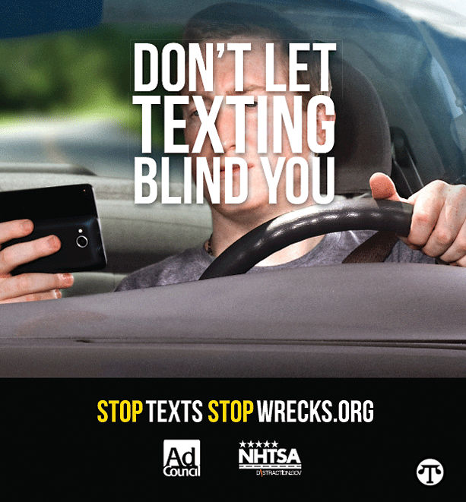

References:

Edgar Synder & Associates. (2015). Texting and Driving Accident Statistics. Retrieved 2015, from <https://www.edgarsnyder.com/car-accident/cause-of-accident/cell-phone/cell-phone-statistics.html>

The Zebra. (2019). 2019 Texting and Driving Statistics. Retrieved Jan 2, 2019, from <https://www.thezebra.com/texting-and-driving-statistics/>

Stop the Texts Stop the Wrecks (2015). Don’t Let Texting Blind You [Advertisement]. Retrieved from <https://stoptextsstopwrecks.org/>